**Cloud Computing Lab**

**(MCAE 0372)**

**ASSIGNMENT - 1**



**Submitted by: Submitted To:**

Khushi Varshney Mrs. Ruchi Agrawal

MCA II A (Asst. Professor)

2284200103 Department of CEA

**Building Network Topologies using CISCO Packet Tracer**

**Objective**- To learn about the different networking devices and getting familiar with Cisco packet tracer.

**Description**- A topology is physical and logical arrangement of nodes in a network. The four basic topologies are star, bus, mesh, and ring.

**Outputs-**

* **Ring Topology**

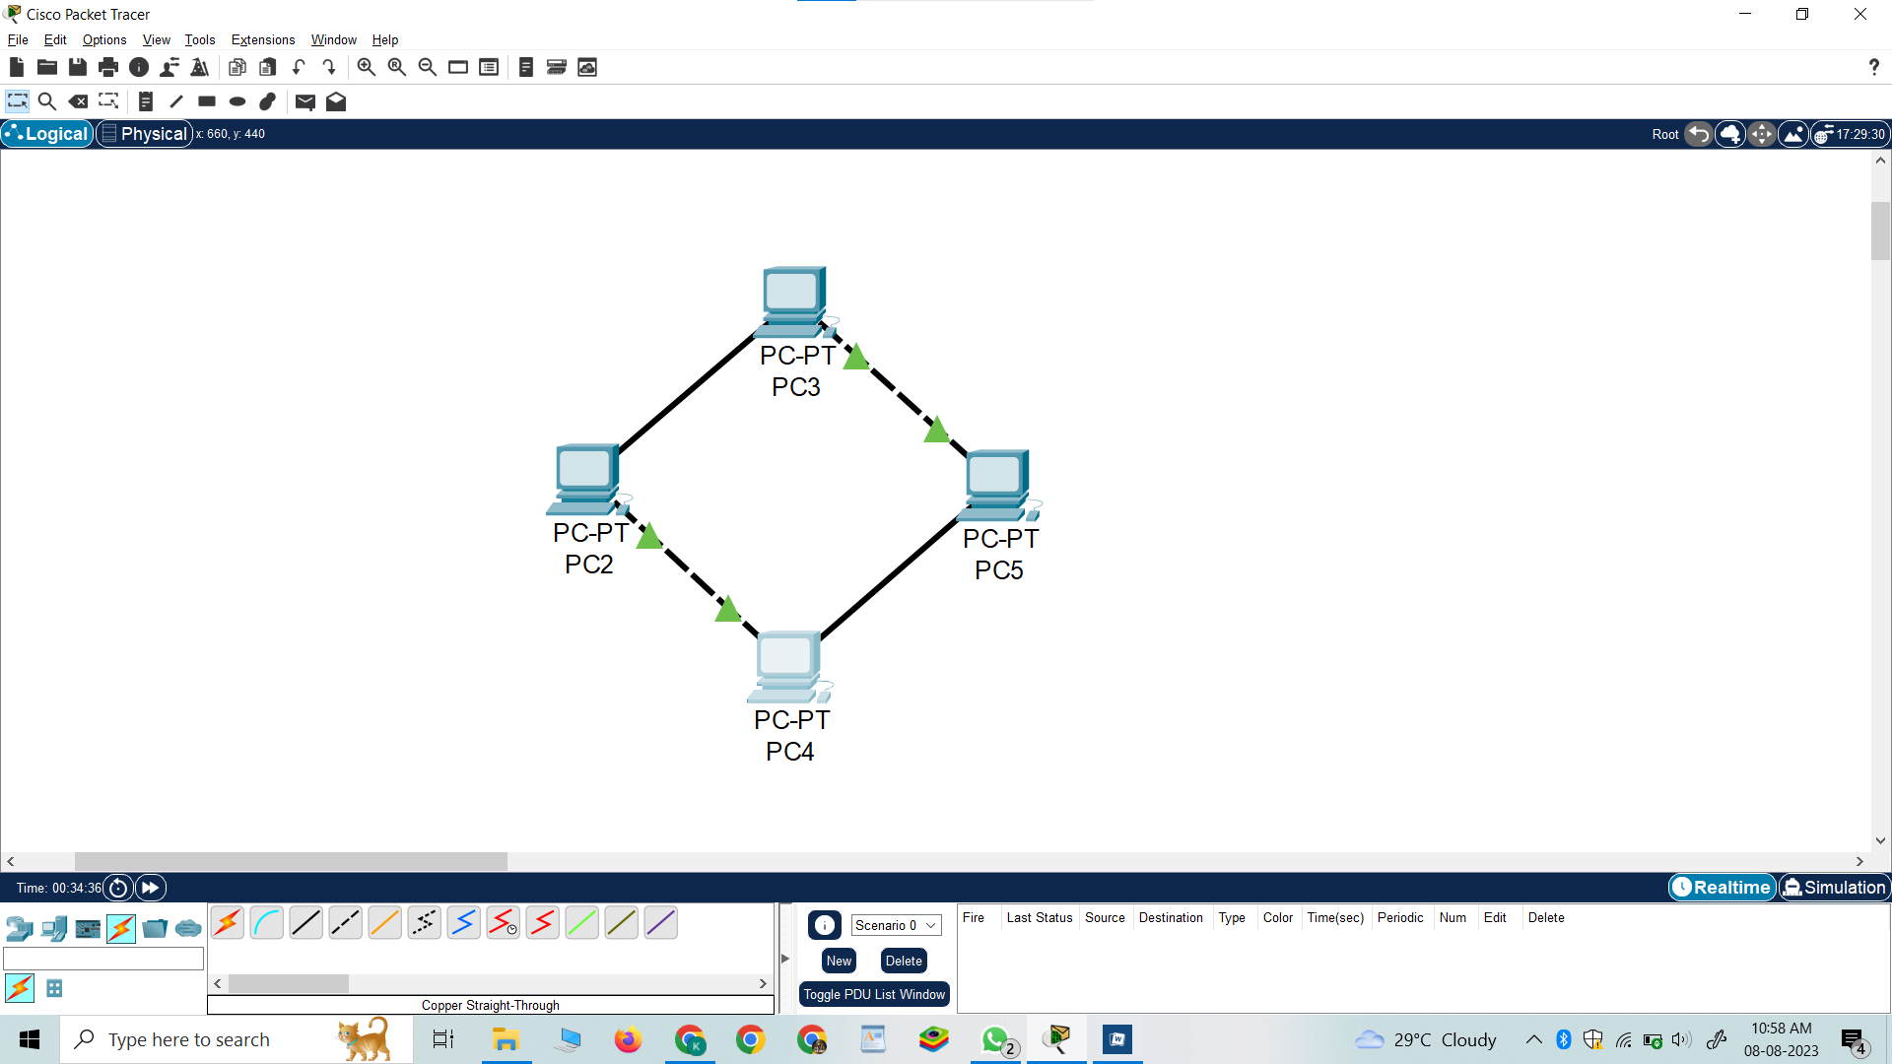

* **Mesh Topology**

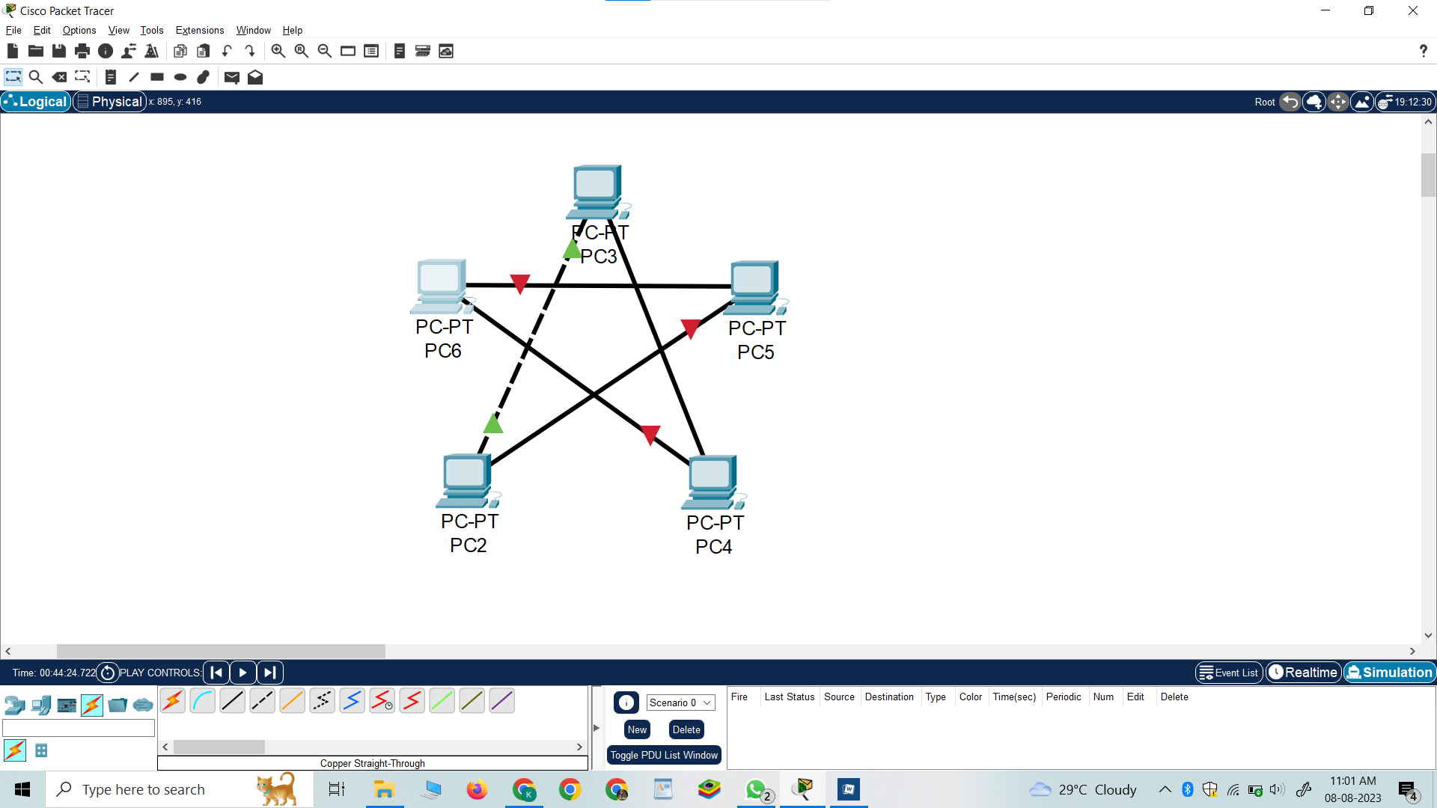

* **Star Topology**

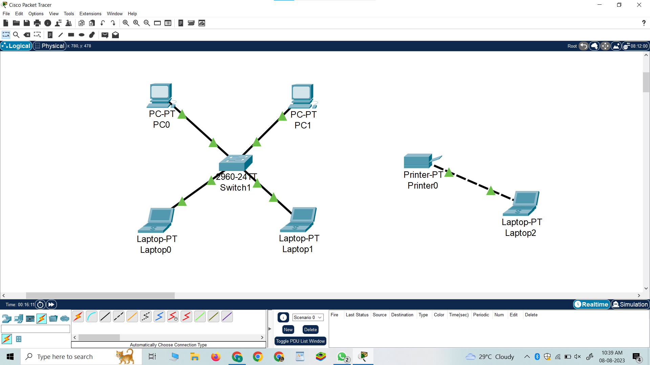

* **Bus Topology**

